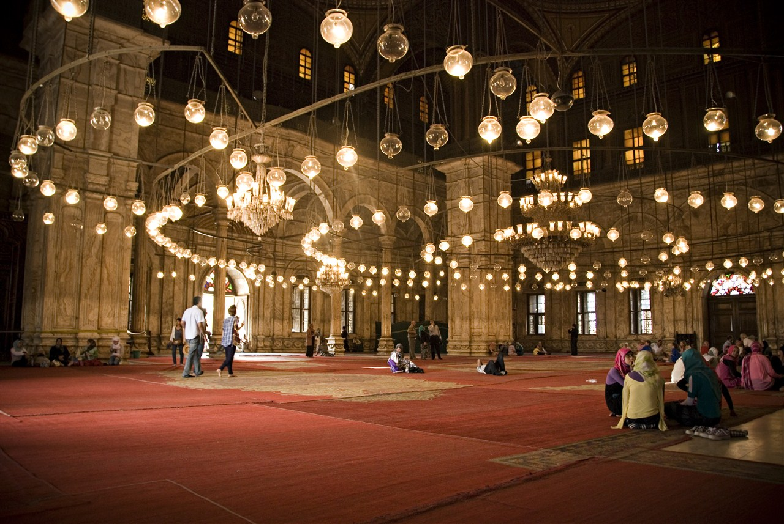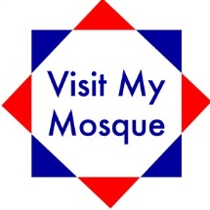

Free refreshments

Guided tours

Q&A session

& more…!

No prior booking necessary

For further information, contact:

**[Insert Contact Person Email/Phone]. [Insert Web Address]**

**You are invited to our**

**Mosque Open Day**

**Date:** [Insert Date]

**Time:** [Insert Time]

**Address:** [Insert Address and Post Code]

(free parking available on site)

[Insert your logo]